Abstract—Results from our global calculations indicate the PRATT fuel design is capable of reducing the time and size requirements on nuclear waste storage facilities while increasing the proliferation resistance of the commercial reactor fuel cycle. In its current configuration, the PRATT design has an 885 kg net consumption of plutonium, an 1138 kg net consumption of ²³⁹Pu and a 256 kg net consumption of neptunium. These goals can be achieved while maintaining low hot channel factors with a maximum value of 2.119 and even with a reduced boron worth due to the large initial loading of plutonium the beginning of cycle boron concentration is 978 ppm. The moderator coefficient of reactivity was shown initially to be -41.226 pcm/°F and continues to be negative throughout the cycle length.
Thorium-Based Mixed-Oxide Fuel for the Consumption of Transuranic Elements in Pressurized Water Reactors
Jason R. Haas, Brock E. Palen, and Crystal L. Thrall
Department of Nuclear Engineering and Radiological Sciences
University of Michigan, Ann Arbor, MI 48109-2104
jayhaas@umich.edu, brockp@umich.edu, thrall@umich.edu

INTRODUCTION
H.T.P.Global Technologies presents the Design Report for the Proliferation Resistant Advanced Transuranic Transmuting (PRATT) fuel design. Assembly and global calculations have been performed to investigate the PRATT fuel design depletion, safety and economical characteristics. The goal of the PRATT design is to reduce the requirements on nuclear waste storage facilities, both time and size, while increasing the proliferation resistance of the commercial reactor fuel cycle. The PRATT design accomplishes these goals by being partially loaded with reactor grade plutonium and minor actinides both of which are produced by current pressurized water reactors (PWR) and normally disposed of as waste. The cycle has a net destruction of transuranic elements, again decreasing nuclear waste and radiotoxicity. In order for the PRATT fuel design to be both economically feasible and implemented in the near future it is designed for existing Westinghouse 4-loop pressurized water reactors.
The PRATT fuel design, a modified thorium (Th) cycle, has advantages over the uranium (U) cycle currently used in commercial reactors. The Th cycle offers proliferation resistance because it does not produce plutonium (Pu) like current U fuel cycles, which can be used to construct nuclear weapons. Thorium oxide fuel has been reported to be more robust than uranium oxide, and it is fertile, meaning it will produce a fissile isotope, ²³³U, which can fuel the reactor later

in life leading to a longer fuel cycle length. A longer cycle length will increase profits because the reactors can operate longer with fewer outages for refueling. The objective of this
design report is to describe the methods used to model the PRATT fuel design, explain the results, and highlight its advantages.

History
Current fuel cycles produce long-lived radioactive waste isotopes and present a proliferation concern by producing plutonium. The current problems in the authorization of the Yucca Mountain site have shown the development and verification of a repository for long lived radioactive sources to transuranic (TRU) isotopes, is extremely difficult. The elimination of these sources (radioactive for approximately 1,000,000 years) via transmutation removes the need of developing a long term repository [1]. The TRU sources which account for one weight percent of spent nuclear fuel (SNF) can instead be placed inside a reactor and transmuted into short-term sources. The transmuted material could then be placed in a short term storage facility, which would be easier to develop because the sources are present for only approximately one hundred years. The combination of the PRATT fuel design and short-term storage facilities would take the SNF from current power plant on site storage, reducing the proliferation risk by consolidating the nuclear waste. Current fuel cycles have a net production of Pu which introduces an avenue for acquiring nuclear weapons.

advantages to the pratt design
Even though the current U cycle is known to be safe, economical and reliable, there are many reasons to consider alternative nuclear fuels. The PRATT design will have a positive impact on the nuclear industry as well as the general population. Using the PRATT fuel, the nuclear industry can improve the public’s perception of nuclear power, by increasing proliferation resistance and decreasing nuclear waste radiotoxicity. The increased proliferation resistance is an effect of a net consumption of Pu while the decreased waste radiotoxicity is an effect of burning minor actinides. Burning minor actinides decreases the time requirements on spent fuel storage at Yucca Mountain and creates more room in on-site SNF storage.
The PRATT system is superior to Generation IV transmutation designs because it can be used in existing Westinghouse PWRs. Implementing the PRATT design eliminates the need for new reactor construction, significant research and development costs and the associated risk of a dramatically new technology. The time required for research and development is also significantly reduced allowing quicker realization.

methods
The methods used thus far fall into three categories: simulation software, analysis software and hand calculations. The three methods were used in an iterative fashion to arrive at the assembly and global level results provided in this report.

Simulation Software
The simulation software used is a proprietary package from Westinghouse Electric Company called APA (Alpha, Phoenix, ANC) [2]. APA was used to model and deplete the PRATT PWR fuel assemblies to the desired discharge burnup. The APA code package provides the relative power distributions in the fuel assemblies, k-inf (multiplication factor excluding leakage) and nuclide inventories for each depletion time step [3]. Relative power is defined as the peak to average power at a given point in the assembly where the volume averaged relative power is normalized to 1.0. Significant effort was devoted to determine the process needed to use MAs in the Westinghouse APA package. A procedure was found to enable the insertion of MAs into a global ANC calculation.

Analysis Software
The analysis software was primarily written in house to dissect the APA results. In house perl scripts were written to allow for accelerated advancements of our fuel designs due to fast data mining. The software can also provide both numeric and visual comparisons. Visualization of the results was done with OpenDx, giving a more intuitive way of seeing differences at distinct burnup steps and between assembly revisions.
A program was also developed to accelerate the thermal hydraulic calculations. The thermal analysis program assumed homogeneous axial loading and a core loading of a single a core average middle enrichment assembly. The initial temperature profiles were made assuming no temperature dependence. The fundamental mode for the power distribution is a cosine shape with zero power at the end points. A rough estimate of temperature dependence on the core power was done. All values for bulk coolant rise, fuel surface temperature, and fuel centerline temperature were calculated again using the power with thermal feedback.
The thermal hydraulic program broke the core into 1000 points along its axis which were then averaged into 100 meshes with a single temperature. This average temperature found for each mesh is taken from the bulk coolant temperature from the fundamental mode. The average was then fed as the inlet temperature to the Westinghouse lattice physics code PHOENIX. The two group cross sections generated by these PHOENIX runs were used as the cross sections in the meshes they represent. In total there are 98 meshes that represent active fuel in the core and 2 representing the top and bottom reflectors for a total of 100 meshes. The meshes were fed into the ONED two group diffusion code to produce a new relative axial power which is then used to calculate new bulk coolant temperatures, fuel centerline and surface temperature. A flow chart of the program is shown in Figure IV-1.

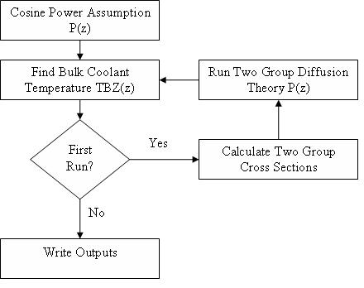
Figure IV-1: The in-house thermal hydraulic program flow chart.

Hand Calculations
Hand calculations provide the number densities for the minor actinide (MA) compositions for select fuel pins. The ALPHA portion of the APA package is not equipped to handle MA isotopes; therefore, the hand calculated number densities have to be fed into PHOENIX.

Assembly Configurations
Shown in Figure V-2 through Figure V-6 are the five different denatured thorium-based mixed oxide fuel (TMOX) assembly configurations. Each design is similar with only slight enrichment and pin position modifications. The design is based off of a typical 17x17 PWR assembly but with MA pins and two distinct regions [4]. Region 1 is central and consists of (²³⁵U, ²³⁸U, Th)O₂ pins with slightly higher than normal enrichment of ²³⁵U. Region 1 for each assembly design has thorium make up 75% of the fuel weight. Region 2, an outer TMOX region is comprised of (Th, Pu)O₂ pins with varying Pu enrichment and varying burnable absorber density. The initial values of Pu fuel weight percents were taken from Shwargeraus and later modified in the assembly optimization process [5]. The Pu is reactor grade and is discussed in more detail below. Integral Fuel Burnable Absorber (IFBA) coatings were used as the burnable absorber in both region 1 and 2. The assemblies were originally based on seed blanket designs by Galperin, but were later modified [6]. In addition pins composed of minor actinides from spent nuclear fuel in an oxide form are placed throughout the assembly. The minor actinide, MA, pins act similar to a burnable absorber pin. The weight percent composition of the MA and Pu come from spent nuclear fuel from a light water reactor initially loaded with UO₂ enriched to 4.2 weight percent ²³⁵U after a burnup of 50 MWd/kgHM and a cooling period of 10 years [4]. The isotopic weight percents of MA and Pu are listed in Table V-1 and Table V-2 respectively.

Table V-1: MA LWR spent fuel MA compositions after 50 MWd/kgHM, 10 years of cooling and initially loaded with U0₂ enriched to 4.2 wt%.

Weight Percent by Component
Nuclide | Waste MA
²³⁷Np | 49.816
²⁴¹Am | 34.911
²⁴²Am | 0.143
²⁴³Am | 11.042
²⁴²Cm | 0.000
²⁴³Cm | 0.000
²⁴⁴Cm | 3.721
²⁴⁵Cm | 0.323
²⁴⁶Cm | 0.045

Table V-2: Pu composition discharge from a typical PWR fuel cycle enriched to 4.2 wt% ²³⁵U depleted to 50 MWd/kgHM and cooled for a period of 10 years.

Pu Weight Percent by Isotope
²³⁸Pu | 3.18
²³⁹Pu | 56.35
²⁴⁰Pu | 26.62
²⁴¹Pu | 8.02
²⁴²Pu | 5.83

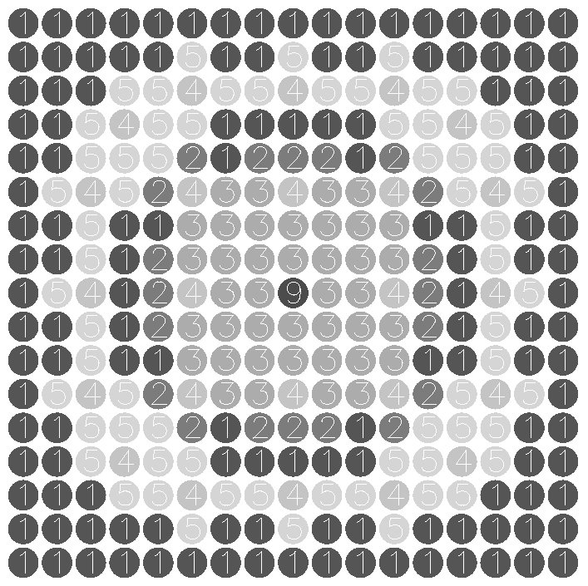
Figure V-2: Pictorial representation of assembly 1, 2, and 4.

Figure V-2 is the assembly map for our assembly 1, 2 and 4. Table V-3 shows the various enrichments for each pin type. The IFBA densities quoted are equal to the reference Westinghouse AP1000 design, or 1.25 times the ALPHA default reference IFBA loading.

Table V-3: Enrichments for assembly numbers 1, 2 and 4 corresponding to the assembly map given in Figure V-2.

Assembly No. | Pu wt% Pin 1  (IFBA Density) | Pu wt% Pin 2 (IFBA Density) | ²³⁵U wt% Pin 3 (IFBA Density)
1 | 12.0  (1.25) | 9.0  (1.25) | 10.0  (1.25)
2 | 18.0  (1.25) | 12.0  (1.25) | 15.0  (1.25)
4 | 12.0  (No IFBA) | 12.0  (1.25) | 13.0  (1.25)

Figure V-3 is the assembly map for our assembly number 3. The basis for the assembly design came from Yamamoto, where he placed the lowest enriched Pu in the corners [7]. The enrichment specifics are labeled below the assembly map. Each of the fuel pins, the two Pu enrichments and the U-Th region are coated with IFBA with a density again equal to 1.25 times the ALPHA IFBA reference density.

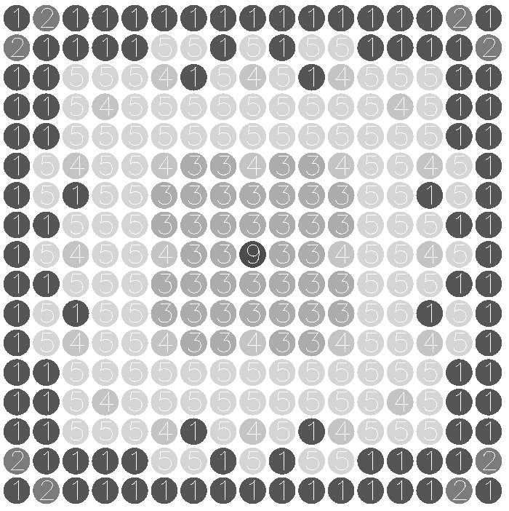
Figure V-3: Pictorial representation of assembly 3.

Figure V-4 shows the assembly map for assembly number 8. The Pu and ²³⁵U enrichments for the pins are labeled below the figure pins 3 and 5,respectively; the lower enriched Pu and the Th-U regions are covered in IFBA with a density equal again to 1.25 times the ALPHA reference IFBA density. The higher enriched Pu region contains no IFBA.

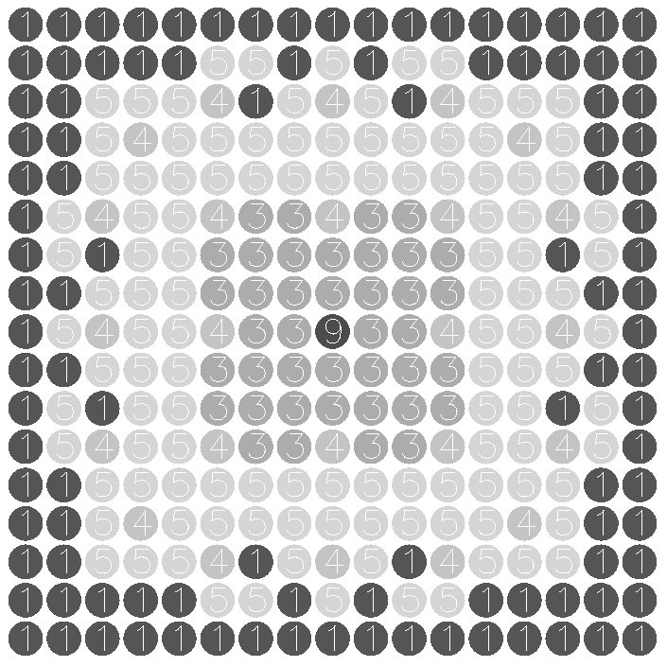
Figure V-4: Pictorial representation of assembly 8.

Figure V-5 shows the assembly map for assembly number 5. The Pu and ²³⁵U enrichments for the pins are labeled below the figure and the Pu and U pins are all covered in IFBA with a density equal again to 1.25 times the ALPHA reference IFBA density.

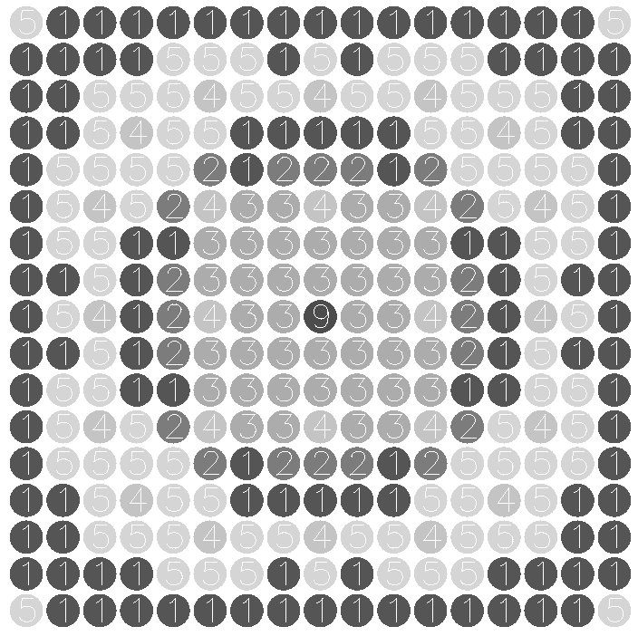
Figure V-5: Pictorial representation of assembly 5.

Figure V-6 is the assembly map for assembly 6 and 7. Table V-4 shows the various enrichments for each pin type. The IFBA densities quoted are equal to the reference Westinghouse AP1000 design, or 1.25 times the ALPHA default reference IFBA loading.


Figure V-6: Pictorial representation of assemblies 6 and 7.

Table V-4: Enrichments for assembly numbers 6 and 7 corresponding to the assembly map given in Figure V-6.
Assembly No. | Pu wt% Pin 1  (IFBA Density) | Pu wt% Pin 2 (IFBA Density) | ²³⁵U wt% Pin 3 (IFBA Density)
6 | 12.0  (1.25) | 8.0  (1.25) | 10.0  (1.25)
7 | 18.0  (1.25) | 12.0  (1.25) | 15.0  (1.25)

Two tables summarizing the parameters of all eight assemblies are included in the Appendix and are labeled Tables A1 and Table A2.

Loading Pattern
Using the eight assemblies described in Section V. Assembly Configurations, a loading pattern was created. As will be discussed in further detail later, a uniform axial loading pattern caused the axial power distribution to be heavily skewed towards the bottom of the core. In order to draw the power higher in the core a three zone enrichment design was employed as shown in Figure VI-7. The bottom zone used lower enriched assemblies and covered the first 25”, the upper zone used slightly higher enriched assemblies and covered the top 15” of the core but the majority of the core, 104” utilized the loading pattern described by Figure VI-8.
On the outside of core, assemblies with the highest enrichments were used. The inside of the core is composed of two different assemblies, both with lower enrichments than the outer assemblies in a modified checker board pattern. The numbers in the boxes in Figure VI-8 correspond to the assembly numbers as described earlier. As stated in the Introduction the core loading pattern is for existing Westinghouse 4-Loop pressurized water reactors which are designed to fit 193 assemblies.

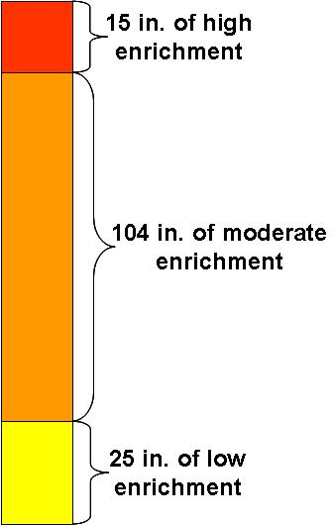
Figure VI-7: Axial enrichment zones.

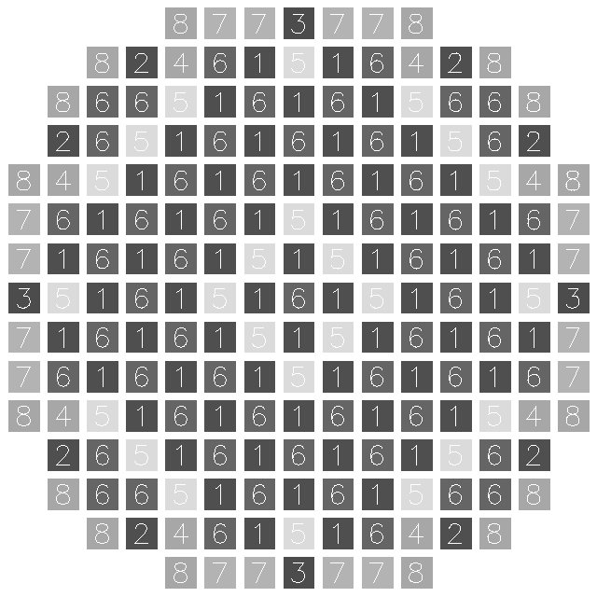
Figure VI-8: Core loading pattern for the central axial zone showing the placement of the 193 assemblies.

The loading pattern for the bottom 25” of the core was not optimized to the same extent as the middle region. It used, as can be seen in Figure VI-9, only three different assembly types. The AP1000 design only uses one assembly type in the bottom zone of the core, whereas the PRATT design required three different assembly types to help reduce axial power peaking without significantly increasing the cost or difficulty of fuel fabrication.
The loading pattern for the top 15” of the core was also not fully optimized; however, three different assembly types were used to reduce power peaking factors. The top axial zone loading pattern is shown in Figure VI-10.

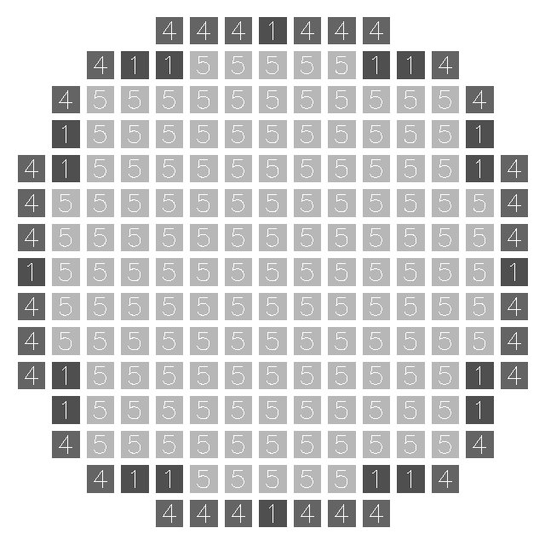
Figure VI-9: Core loading pattern for the bottom axial zone (25").

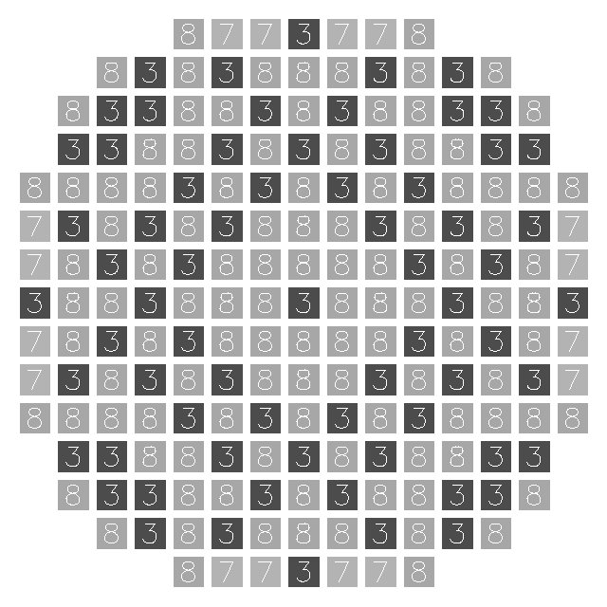
Figure VI-10: Core loading pattern for the top axial zone (15").

The loading pattern specifics for the three regions are laid out in Table VI-5, showing the number of the different assemblies loaded into the core.
Table VI-5: The PRATT fuel design loading pattern specifics.
Assembly No. | 1 | 2 | 3 | 4 | 5 | 6 | 7 | 8
Bottom Zone | 20 | 0 | 0 | 32 | 141 | 0 | 0 | 0
Central Zone | 60 | 8 | 4 | 8 | 24 | 57 | 16 | 16
Top Zone | 60 | 0 | 69 | 0 | 0 | 0 | 48 | 16

Assembly Level Results
Assembly level infinite multiplication values (k-inf) and pin-pin power peaking values were calculated for each of the 8 assemblies used in the PRATT fuel design.

Infinite Multiplication Values
The eight assemblies outlined in section V Assembly Configurations were designed to have a distribution of initial k-inf values from 1.00 – 1.25 in accordance with a typical Westinghouse PWR three batch fuel management cycle. Thorium’s fertile nature combined with thorium fuels being more robust than the typical uranium oxide fuel; a cycle length of 20 MWd/kgHM was targeted instead of the standard 15 MWd/kgHM [8,9]. Initial enrichments of U, Th, Pu and BA were adjusted to assure the distribution of k-inf values.
Figure VII-11 and Figure VII-12 show the k-inf values of the eight assemblies as a function of burnup. The thorium fuel cycles have a very gradual downward slope especially after about 10 MWd/kgHM, the approximate time when the burnable absorbers are depleted. The k-inf is maintained by the production of fissile ²³³U through the Th chain and as a result can maintain a much longer cycle length than typical uranium oxide fuels, before refueling is necessary.

Figure VII-11: K-inf values for the four lower enriched assemblies (1, 4, 5, 6) as a function of burnup in MWd/kgHM.

Figure VII-12: K-inf values for the four higher enriched assemblies (2, 3, 7, 8) as a function of burnup in MWd/kgHM

The pin to pin power peaking factors for each different assembly are shown in Figure VII-13 and Figure VII-14 as a function of burnup. Maximum peaking values occur after 10 MWd/kgHM after the IFBA has completely “burned off” and the Th has bred a sufficient amount of ²³³U. A pin to pin power peaking value around 1.2 means in an assembly at least one pin is producing 20% more power than the assembly average. The pins with that high of a factor will deplete earlier and could be in risk of violating thermal hydraulic limits. The PRATT design never exceeds a pin to pin power peaking value of 1.19.

Figure VII-13: Pin to pin power peaking values for the low enriched assemblies (1, 4, 5, 6) as a function of burnup MWd/kgHM.

Figure VII-14: Pin to pin power peaking values for the higher enriched assemblies (2, 3, 7, 8) as a function of burnup MWd/kgHM.

Power peaking values should be kept as close to unity as possible to ensure an even radial fuel burnup and to decrease cladding stresses due to elevated fuel temperatures resulting in an increase of the obtainable fuel cycle length.

Global Calculation Results

Boron Concentration
A major challenge when designing a primarily plutonium based light water reactor is controlling the soluble boron concentrations necessary to compensate for excess reactivity. In addition, the presence of high absorbing ²³⁹Pu and ²⁴⁰Pu will compete with the control materials for neutrons, significantly reducing the reactivity worth of the soluble boron; thereby requiring a much higher initial concentration. However, the concentrations need to be kept moderate (below 1500 ppm) to ensure a negative void coefficient. The boron concentration for the PRATT design is compared with the Westinghouse AP1000 design in Figure VIII-15. Initially there is a concentration of 978 ppm which is below the AP1000 value of 1083 ppm. The cycle length cannot exceed the point where the boron concentration reaches zero. Our goal to obtain a cycle length of 20 (MWd/kgHM) was achieved and corresponds to a soluble boron concentration of 16 ppm.

Figure VIII-15: Boron concentration as a function of burnup, MWd/kgHM, comparing the PRATT and AP1000 designs.

Power Peaking Factor
A relatively smooth radial core power distribution indicates the loading scheme and use of burnable absorbers is adequate. The maximum overall hot channel factor, F_{q}, defined as the maximum radial power peaking factor times the axial power peaking factor is plotted as a function of burnup in Figure VIII-16. The overall hot channel factors of the PRATT design are compared with those from the AP1000. Acceptable values of F_{q} should be below 2.5, the PRATT design falls under this criterion with a beginning of life, before xenon buildup, value of 2.1 and steadily decreases with burnup.

Figure VIII-16: Maximum overall hot channel factor, F_{q}, as a function of burnup in MWd/kgHM comparing the PRATT fuel design with the AP1000.

Another peaking factor of interest is the radial power peaking factor, or the assembly power level normalized by the core average assembly power level. The ANC code will output the worst radial assembly power peaking values for each assembly location, meaning the maximum radial power peaking factors might occur at different axial planes. Radial power peaking factors are reported at two different time steps, BOC and EOC, and never exceed the industry limit of 1.5. The maximum value of the optimized central axial zone’s radial power peaking value hovers around 1.38 throughout the cycle length. Two separate radial peaking factor diagrams are highlighted in Figure VIII-17 and Figure VIII-18 below.

BU = 0.0 MWd/kgHM
 | 1 | 2 | 3 | 4 | 5 | 6 | 7 | 8
1 | 1.18 | 1.09 | 1.11 | 1.17 | 1.29 | 1.16 | 1.11 | 1.39
2 | 1.09 | 1.1 | 1.15 | 1.27 | 1.19 | 1.28 | 1.13 | 1.225
3 | 1.11 | 1.15 | 1.26 | 1.19 | 1.29 | 1.18 | 1.27 | 1.274
4 | 1.17 | 1.27 | 1.19 | 1.28 | 1.17 | 1.17 | 1.3 | 1.38
5 | 1.29 | 1.19 | 1.29 | 1.17 | 1.16 | 1.28 | 1.31
6 | 1.16 | 1.28 | 1.18 | 1.17 | 1.28 | 1.25 | 1.37
7 | 1.11 | 1.13 | 1.27 | 1.3 | 1.31 | 1.37
8 | 1.39 | 1.22 | 1.27 | 1.38
Figure VIII-17: Maximum radial power peaking values of optimized central zone at 0 BU.

BU = 20 MWd/kgHM
 | 1 | 2 | 3 | 4 | 5 | 6 | 7 | 8
1 | 1.29 | 1.17 | 1.2 | 1.29 | 1.41 | 1.23 | 1.11 | 1.3
2 | 1.17 | 1.18 | 1.24 | 1.42 | 1.3 | 1.35 | 1.13 | 1.15
3 | 1.2 | 1.24 | 1.41 | 1.31 | 1.39 | 1.21 | 1.23 | 1.16
4 | 1.29 | 1.42 | 1.31 | 1.4 | 1.22 | 1.16 | 1.18 | 1.21
5 | 1.41 | 1.3 | 1.39 | 1.22 | 1.17 | 1.24 | 1.2
6 | 1.23 | 1.35 | 1.21 | 1.16 | 1.24 | 1.175 | 1.21
7 | 1.11 | 1.13 | 1.23 | 1.18 | 1.2 | 1.21
8 | 1.3 | 1.15 | 1.16 | 1.21
Figure VIII-18: Maximum radial power peaking values of optimized central zone at 20 BU.

Axial Power Distribution
As described earlier the PRATT fuel design employs three different axial enrichment zones a low, medium and elevated enrichment. Before zoning the PRATT fuel the axial relative power distribution was heavily bottom skewed as shown in Figure VIII-19 the ANC quoted axial offset factor was -36% at BOC. A bottom skewed power distribution is unwanted because the fuel will not be depleted uniformly throughout the core, which decreases the fuel utilization and achievable cycle length in addition to rapidly heating the moderator. Ideally the moderator should be gradually heated as it travels up through the core.

Figure VIII-19: The PRATT axial relative power distribution before axial zoning.

After implementing the three axial enrichment zones a new relative power distribution, shown in Figure VIII-20, was created. As can be seen the power was drawn closer to the core center and flattens throughout the cycle length. ANC quoted a new BOC axial offset factor of -10.6% which lies within the industry standard of keeping the axial offset smaller (less negative) than -15%.

Figure VIII-20: The axial relative power distribution of the PRATT fuel design at four different burnups.

Isotope Inventories
The main goal of the PRATT fuel design was to have a net consumption of transuranic elements specifically fissile isotopes and ²³⁷Np over the cycle length. ²³⁷Np is one of the longest living radioactive waste sources having a half life of 2144000 years and fissile isotopes introduce an avenue for acquiring an atomic weapon.
Figure VIII-21 tracks the fissile isotope inventories throughout the burnup of the PRATT fuel. Both ²³⁹Pu and ²³⁵U are consumed throughout the cycle while ²³³U is produced. However, the ²³³U is not considered a proliferation concern because it is protected by a radiation field made up of 4.8 MeV gamma rays coming from the decay of ²³²U to ²²⁹Th. ²³²U is built in along with ²³³U but in a smaller quantity. Unfortunately, the Westinghouse APA package is not designed to track ²³²U so no determination can be made on its abundance in the fuel but it has been reported to be sufficient enough to reduce the proliferation risk introduced by the ²³³U [8].
The net inventory change of Pu, Np and TRUs, in general, in kg over one cycle for the PRATT fuel and AP1000 are shown in Figure VIII-22. It is shown the PRATT design has a net destruction of Pu, Np and TRUs while the AP1000 has a net production of all three. The net inventory balances for most nuclides of interest are shown in Table VIII-6 for both the AP1000 and the PRATT design. Of interest are the 1138 kg of ²³⁹Pu and 256 kg of ²³⁷Np consumed by the PRATT design while the AP1000 produces 427 kg of ²³⁹Pu and 13.2 kg of ²³⁷Np. It should be noted, however, that the PRATT design has 37 more assemblies than the AP1000 but is two feet shorter because it is designed for existing Westinghouse 4-loop reactors.

Figure VIII-21: Fissile isotope inventory in kg as a function of burnup MWd/kgHM.

Figure VIII-22: Transuranic inventory changes over one cycle length for the PRATT fuel and AP1000 design.

Table VIII-6: Net inventory balance for the AP1000 and PRATT design. All values are in kg and the delta represents the change over one cycle length.
PWR Configuration | AP1000 |  | PRATT
Net Inventory Balance (kg/core) | BOC  (kg) | ∆  (kg) | BOC  (kg) | ∆  (kg)
Thorium | --- | --- | 48334 | -461.5
Uranium | 83301 | -2366 | 2466 | 141
²³³U | --- | --- | 0 | 350
²³⁵U | 2827 | -1399 | 1089 | -241
²³⁷Np | 0 | 13.2 | 2233 | -256
Plutonium | 0 | 622 | 9557 | -885
²³⁹Pu | 0 | 427 | 5386 | -1138
Americium | 0 | 2.5 | 518 | 32.7
²⁴¹Am | 0 | 1.1 | 16.3 | 46.2
Curium | 0 | 0.4 | 183.3 | 49.1
Transuranics | 0 | 646 | 12491 | -1059
Heavy Metal | 83301 | -1728 | 63291 | -1334

Between the years of 1968 and 2002, the United States has discharged 165,854 assemblies which equates to 47,023.4 MTHM. Of this spent nuclear fuel, 1% is composed of TRUs. Given that the total TRU destruction per PRATT cycle is 1059 kgHM, it will take approximately 18 fuel cycles to destroy the TRUs in the current SNF stockpile assuming 25 plants use the PRATT design.

T/H Results
Thermal hydraulic, T/H, analysis of the PRATT core utilized the same coolant flow rate as existing Westinghouse four loop plants. The four loop design has a total coolant flow rate of 17351 kg/s with an inlet temperature of 552 K. The full power of the core is rated at 3411 MW_{th} with 193 assemblies. Each assembly is a 17x17 array of fuel pins, but with 24 guide tubes and one instrumentation tube all of which produce no power. The core averaged power per fuel loaded pin is 66.95 kW/pin while 0.34 kg/s of coolant passes by every pin. The four loop reactor design has an active fuel height of 12 feet, over this distance the coolant enthalpy rise is 196.6 kJ/kg.
Figure VIII-23 shows both the fundamental mode and the coupled nuclear and thermal hydraulic (NTH) adjusted heat flux. The lower moderator temperature in the bottom part of the core increases neutron moderation allowing more neutrons to reach a low thermal energy where fission cross sections increase sharply. As expected the effect of the lower moderator temperature pulls the peak power from the center of the core down to around 130 cm or a -20% offset from center. In comparison, the AP1000 has a peak heat flux of 1.12 MW/m² offset -33% from center. The lower heat flux of the PRATT fuel results in a safer design by reducing the stress and thermal wear placed on the cladding and support material. The decreased wear on structural materials decreases the probability of fuel assembly failure and results in longer structural material life.

Figure VIII-23: Axial heat flux distribution for the PRATT and AP1000 designs.

Figure VIII-24 shows the bulk coolant temperature for both the fundamental mode and with temperature feedback. The heat flux adjusted for feedback is already 5 K higher at the center line than the heat flux calculated without feedback. The result is expected as more power is produced lower in the core with temperature feedback. The outlet temperature is the same as should be as the power of the core is the same in both cases. The total temperature rise of the coolant for the four loop plant is 36.4 K.
Figure VIII-24: Bulk coolant temperature for the PRATT fuel design in Kelvin as a function of core height.

Fuel surface temperatures for both with feedback and without feedback are shown in Figure VIII-25. The peak surface temperature occurs 250 cm from core bottom with no feedback and at 176 cm with feedback equaling a -4% offset from center. Again due to the fact that more power is being produced lower in the core, the fuel is going to reach a peak temperature lower in the core. The PRATT surface temperature peaks at 602K, well below clad melting temperatures. The lower surface temperature of the PRATT design improves safety as the clad is operating at a lower temperature allowing for a larger temperature rise before failure in an accident.

Figure VIII-25: PRATT and AP1000 fuel surface temperature in Kelvin as a function of core height.

Figure VIII-26 compares the fuel centerline temperature for the PRATT with and without temperature feedback. The peak centerline temperature for the PRATT fuel is 1455K, which is slightly higher than with no feedback of 1687K. Both temperatures are below the melting temperature of uranium dioxide, 3120K. The peak occurs in the vicinity of 130 cm or -29% offset. The AP1000 has a peak centerline temperature of 1397K at -31% offset from center.
Figure VIII-26: The fuel centerline temperature in units of Kelvin as a function of core height from bottom for both the AP1000 and PRATT fuel designs.

Thermal Hydraulic Value | Value | Offset (%) from Center
Bulk Coolant Rise | 36.3 K | --
Peak Heat Flux | 1.2 MW/m² | -20%
Peak Surface Temperature | 602 K | 5%
Peak Center Line Temperature | 1455 K | -29%
Fuel Average Temperature | 1029 K | -27%

Saftey
One of the most important factors affecting reactor safety, namely criticality and the multiplication factor is the reactor temperature. Several of the parameters entering into the value of k are temperature dependent, and changes in T necessarily lead to changes in k and the reactivity of the system. The extent to which the reactivity is affected by temperature is described in terms of temperature coefficients of reactivity. The moderator temperature coefficient of reactivity determines the ultimate behavior of a reactor in response to changes in fuel temperature and inlet coolant temperature. To ensure safe reactor operation, the moderator coefficient of reactivity, α_{mod}, should be negative meaning any increase in temperature due to an increase in k would eventually lead to a reduction of power and stabilization or reduction in k. For water, the moderator in LWRs, α_{mod} is negative; however, this can change if the concentration of soluble boron is too high. The soluble boron concentration is the highest at BOC as shown by Figure VIII-15, and, therefore the α_{mod} is the least negative (closest to positive) at BOL. The PRATT fuel design has a α_{mod} equal to -41.226 pcm/°F or -74.2 pcm/ °C calculated for a 10K change in temperature at a burnup of 0 MWd/kgHM. Reactivity is commonly quoted in units of pcm, or percent mille (10⁻⁵) of Δk/k [11].
Another coefficient of interest to ensure safe power operation is the power coefficient, the change in reactivity per percent change in power. The power coefficient is equal to the summation of the moderator temperature coefficient of reactivity, the fuel temperature coefficient of reactivity and the void coefficient of reactivity. The PRATT design was found to have a power coefficient of reactivity equal to -29 pcm/%power, calculated with a 5% power change at 0.15 MWd/kgHM. Unfortunately it was also found to have a +7 pcm/%power, calculated with a 5% power change at 0 MWd/kgHM. The positive power coefficient of reactivity but negative moderator temperature coefficient means either the fuel or void coefficient of reactivity must be positive.
The boron worth, or amount of reactivity change induced into the core by a certain amount of boron, was calculated at 0 burnup and is equal to -1.79 pcm/ppm or -313.6 pcm/g/kg. The units of boron worth percent mille of Δk/k per boron part per million. Therefore at BOL the soluble boron contributes -1613.7 pcm towards reactivity but at EOL the value drops to -28.7 pcm. The boron worth is strongly influenced by the presence of plutonium. The high Pu thermal cross section hardens the neutron spectrum and causes the boron capture to be partially shielded. This fact can be further emphasized by comparing the PRATT boron worth with that for a typical UO₂ loaded core, -9.99 pcm/ppm, and another reactor grade (P-Th)O₂ core, -2.98 pcm/pmm [12]. The safety parameters analyzed are summarized in Table VIII-7.

Table VIII-7: PRATT safety parameters.
Parameter | Value | Burnup (MWd/kgHM)
Mod. Temp. Coeff. Reactivity  (pcm/°F) | -41.226 | 0
Power Coeff. Reactivity  (pcm/%Δpower) | 7  -29 | 0  0.15
Boron Worth (pcm/ppm) | -1.79 | 0

Economics
In order to do a preliminary economic analysis of the PRATT fuel cycle, many assumptions about production costs had to be made. The fabrication for MOX fuel and the MA pins were assumed to be $1500/kgHM. The cost of reprocessing was assumed to be $1000/kgHM for both the MAs and MOX fuel. The total cost for MOX and MA production is approximately $156M for one core loading. These estimates are conservative given the current desire to dispose of transuranic waste. Assuming a total cost of $23/kgTh, the thorium fuel would cost $1M. In order to estimate the cost of uranium production the following assumptions were made: $100/SWU for enrichment, $50/kgU for uranium ore, $200/kgU for storage, and $250/kgU for fabrication. The total cost of the uranium is $47M for one core loading. SWU is a quantity called the separative work unit defined as the kg of SWU per kg of product HM and the kg of SWU is proportional to the flow of the product stream. The estimate is assuming a U enrichment of 10-15% ²³⁵U. The option is there to buy highly enriched uranium from the Megatons to Megawatts program and down blend it which would most likely be less costly. The cost to operate and maintain a nuclear power plant is estimated to be $0.0074/kWh [13]. Given that our fuel cycle is operational for 20 MWd/kgHM, the cost for operation and maintenance will be $225M. In order to calculate the amount of income, a rate of $0.0721/kWh was assumed for what consumers will be charged for electricity [13]. Using the PRATT design, there would be a net income of $261M per cycle. In reality, this design would be even more cost effective than predicted given that these estimates are conservative.

Conclusion
The inherent reduction in the production of plutonium and higher actinides accompanying the use of thorium-based fuels has resulted in its consideration for controlling the growth of plutonium as well as reducing the existing stockpiles from spent nuclear fuel. Results from our global calculations indicate the PRATT fuel design is capable of reducing the time and size requirements on nuclear waste storage facilities while increasing the proliferation resistance of the commercial reactor fuel cycle. In its current configuration, the PRATT design has an 885 kg net consumption of plutonium, an 1138 kg net consumption of ²³⁹Pu and a 256 kg net consumption of ²³⁷Np. A net consumption of plutonium reduces the quantity of waste to go into long term storage while eliminating material which could be used to construct nuclear weapons. The net consumption of Np decreases the time requirements on a nuclear waste repository. These goals can be achieved while maintaining low hot channel factors having a maximum value of 2.119 and a low initial boron concentration of 978 ppm.
The assemblies in this loading pattern were designed to resemble the current Westinghouse 4-loop, 193 assembly reactor. The eight assemblies were designed to have a distribution of initial k-inf values from 1.00-1.25 in accordance with a typical a PWR three batch fuel management cycle. The reactivity swing over the cycle length is minimized because of the production of fissile ²³³U and as a result Th fuels can maintain a much longer cycle length than typical uranium oxide fuels. Thermal analysis of the PRATT shows that the core meets the final acceptance criteria for licensing by having the fuel surface temperature peak at 602K. In all thermally the PRATT meets or exceeds thermal safety of competing core designs in both fuel reliability and accident mode resistance.
The total cost of operation, maintenance and fuel fabrication will be $429M. Using the PRATT design, there would be a net income of $261M per cycle. Given that the total TRU destruction per PRATT cycle is 1059 kg of HM, it will take just over 18 fuel cycles to destroy the United States SNF stockpile of TRUs assuming 25 plants use the PRATT design.

Acknowledgment
A special thanks goes to Professor John C. Lee for his yearlong guidance and more importantly, his patience as we learned the fundamentals of nuclear physics and nuclear reactor operation. Also thanks should be given to Pam Derry for convincing all of us three years ago to move into 1940 Cooley and while here encourage us to learn some nuclear engineering.
References
- M. TODOSOW, A. GALPERIN, “A Thorium-based Fueld Cycle for Eliminating the Discharge of Trans-Uranium Isotopes from Light Water Reactors,” GLOBAL 2003 Proc. Of GLOBAL 2003Atoms for Prosperity Updaing Eisenhower’s Global Vision for Nuclear Energy, New Orleans, Louisiana,November 16-20, 2003,American Nuclear Society (2003).
- Y. S. LIU et al., “ANC – A Westinghouse Advanced Nodal Computer Code,” WCAP-10966-NP-A, Westinghouse Electric Company (1985).
- T. Q. NGUYEN et al., “Qalification of the PHOENIX-P/ANC Nuclear Design System for Pressurized Water Reactor Cores,” WCAP-11597-NP-A, Westinghouse Electric Company (1988).
- G. YOUINOU, A. VASILE, “Plutonium Multirecycling in Standard PWRs Loaded with Evolutionary Fuels,” 151, 25 (2005).
- E. SHWAGERAUS, P. HEJZLAR, and M.S. KAZIMI, “Use of Thorium for Transmutation of Plutonium and Minor Actinides in PWRs,” Nucl. Technol., 147,53 (2004).
- A. GALPERIN, M. SEGEV, “A Pressurized Water Reactor Plutonium Incinerator Based on Thorium Fuel and Seed-Blanket Assembly Geometry,” Nuclear Technol., 132, 214 (2000).
- R SORENSEN, J. DAVIS, J. LEE, “Thorium-based Fuel for Enhancing Transmutation in Light Water Reactor and Fast Reactor Systems,” Department of Nuclear Engineering and Radiological Sciences University of Michigan, (2005).
- A. YAMAMOTO, T. IKEHARA, T. ITO, “Benchmark Problem Suite for Reactor Physics Study of LWR Next Generation Fuels,” Nucl. Science and Technology, 39, 900 (2002).
- M. TODOSOW, “Use of Thorium in Light Water Reactors,” Nucl. Technol.,151,168 (2005).
- K. WEAVER, S. HERRING, “Performance of Thorium-Based Mixed-Oxide Fuels for the Consumption of Plutonium in Current and Advanced Reactors,” Nucl. Technol.,143, 22 (2003).
- J. Lamarsh, A. Baratta, Introduction to Nuclear Engineering, Prentice Hall (2001).
- C. LOMBARDI, A. MAZZOLA, E. PADOVANI, “Neutronic Analysis of U-free Inert Matrix and Thoria Fuels for Plutonium Disposition in Pressurized Water Reactors,” Journal of Nuclera Materials, 274, 181 (1999).
- D. Bodansky, Nuclear Energy Principles, Practices, and Prospect, 2nd Edition, Springer (2004).

Appendix

Table A1: Assembly Specifications
Parameter | Assembly 9 | Assembly 7 | Assembly 3 | Assembly 8 | Assembly 2
IFBA Pins | 156 | 156 | 256 | 252 | 244
MA Pins | 0 | 8 | 8 | 12 | 20
Region 1
U-Th Pins | 40 | 40 | 40 | 40 | 40
U wt% | 25 | 25 | 25 | 25 | 25
²³⁵U Enrich. | 15 | 15 | 13 | 15 | 15
Region 2
Pu-Th Pins | 224 | 216 | 216 | 212 | 204
Pu wt% (# Pins) | 18 (108)  15 (116) | 18 (100)  15 (116) | 18 (100)  15 (116) | 18 (136)  12 (76) | 18 (140)  12 (64)

Table A2: Assembly Specifications
Parameter | Assembly 4 | Assembly 6 | Assembly 1 | Assembly 5
IFBA Pins | 104 | 252 | 244 | 232
MA Pins | 20 | 12 | 20 | 20
Region 1
U-Th Pins | 40 | 40 | 40 | 40
U wt% | 25 | 25 | 25 | 25
²³⁵U Enrich. | 13 | 10 | 10 | 10
Region 2
Pu-Th Pins | 204 | 212 | 204 | 192
Pu wt% (# Pins) | 12 (204) | 12 (136)  8 (76) | 12 (140)  9 (64) | 12 (116)  9 (76)

 

